• Create logical volume /dev/my_vol/airforce to 200 MB. After mount the size may vary
from 200MB to 250MB and mount it under /IAF.
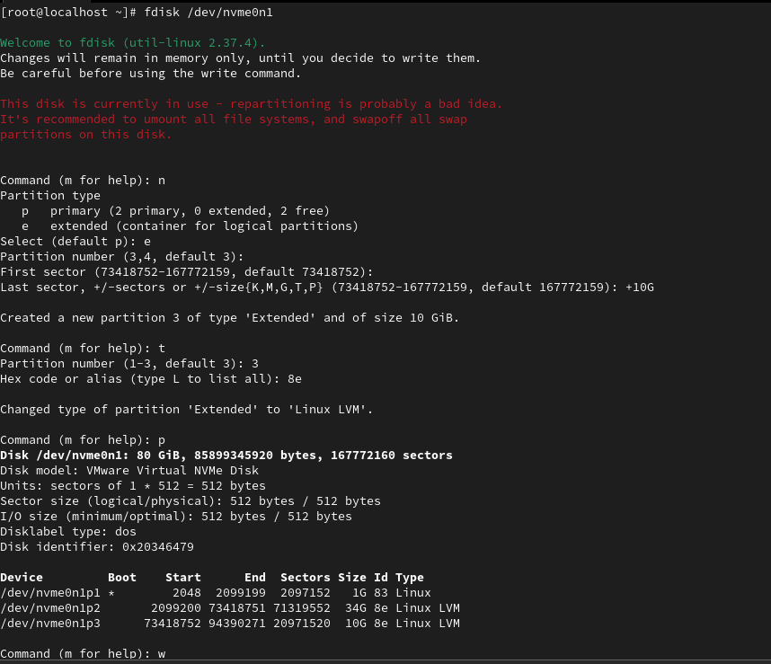
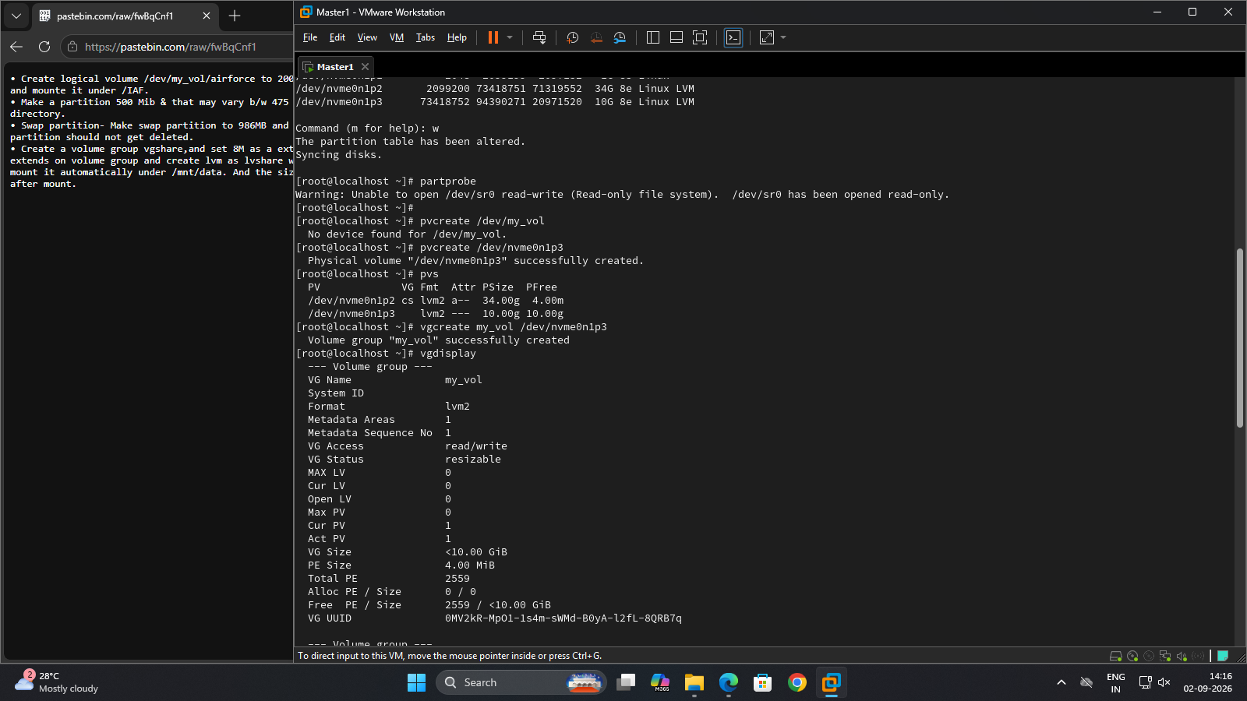
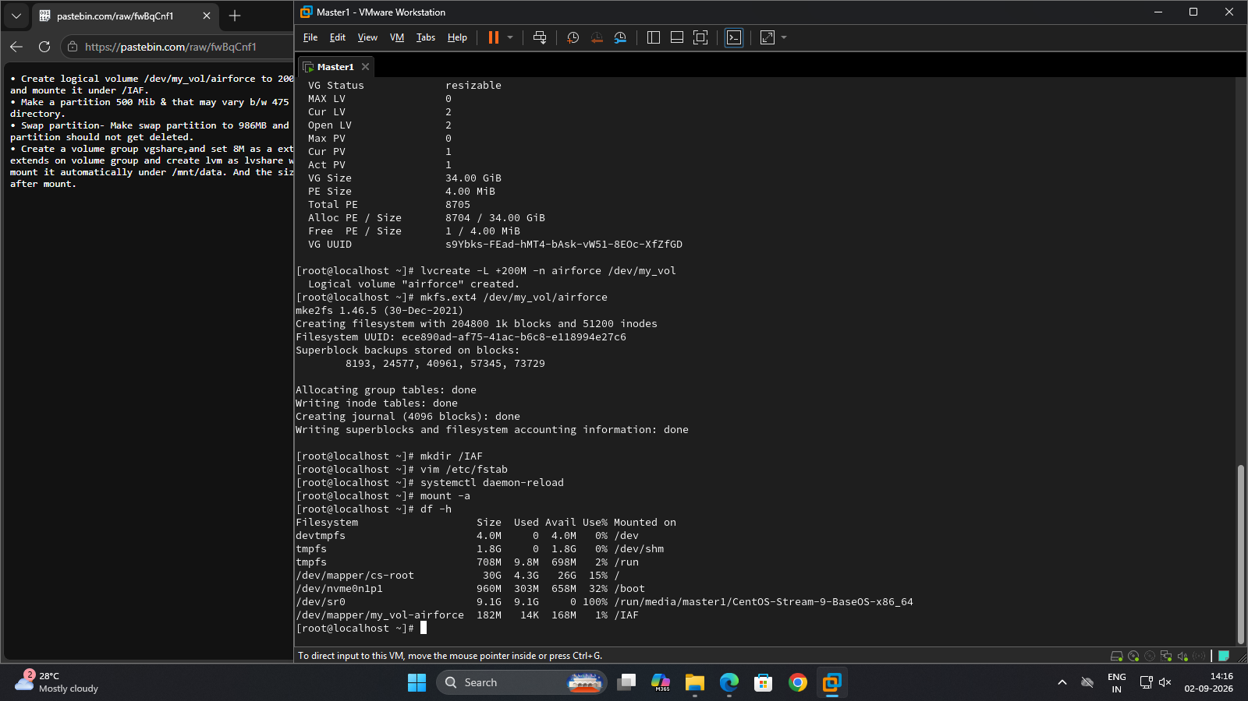
• Make a partition 500 Mib & that may vary b/w 475 Mib to 525 Mib and that should be
mounted on /navy directory.
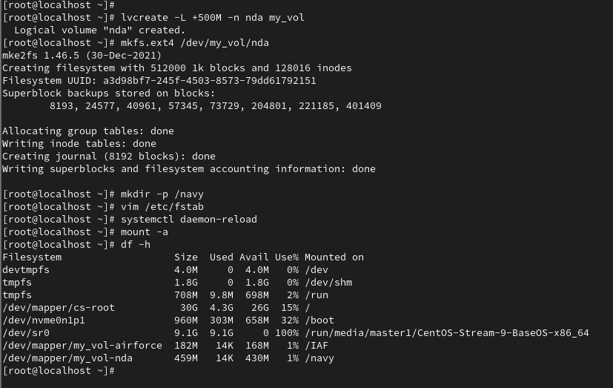
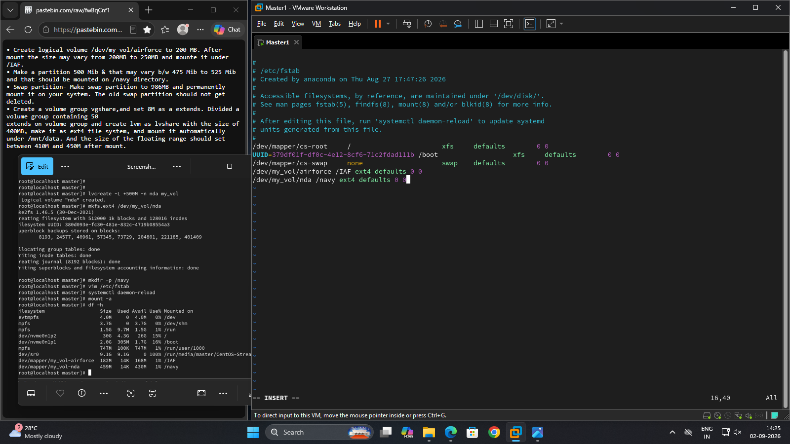
• Swap partition- Make a swap partition to 986MB and permanently mount it on your
system. The old swap partition should not get deleted.
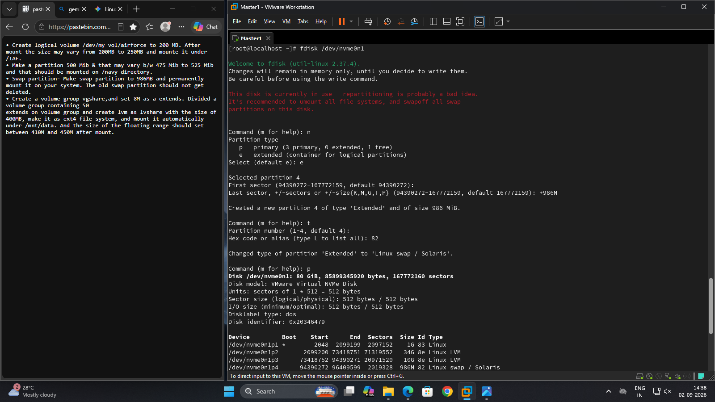
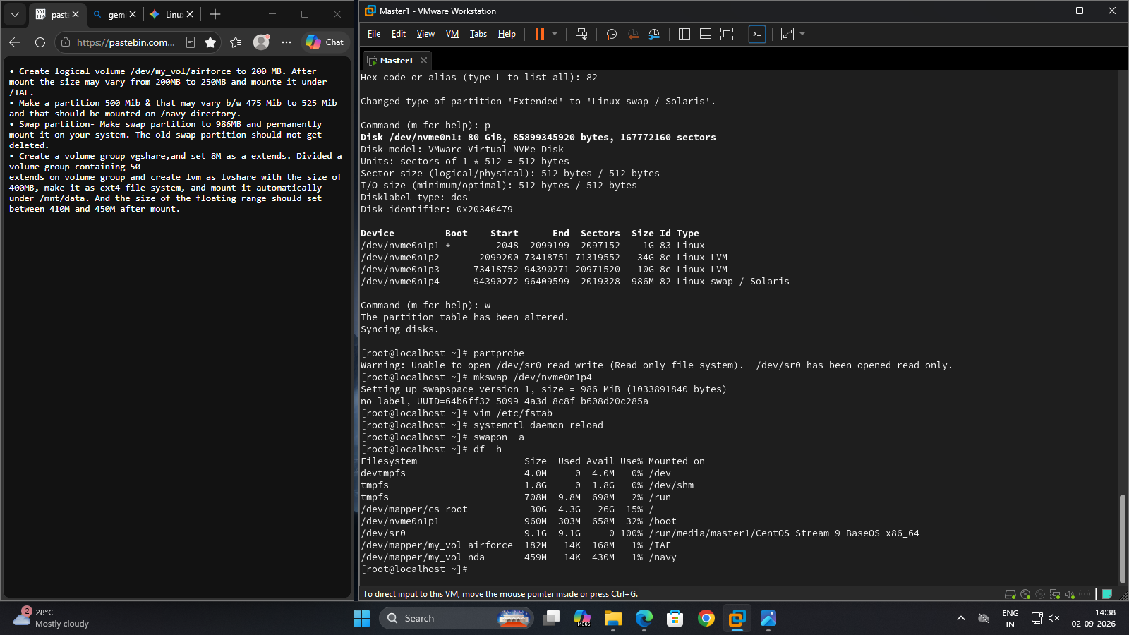
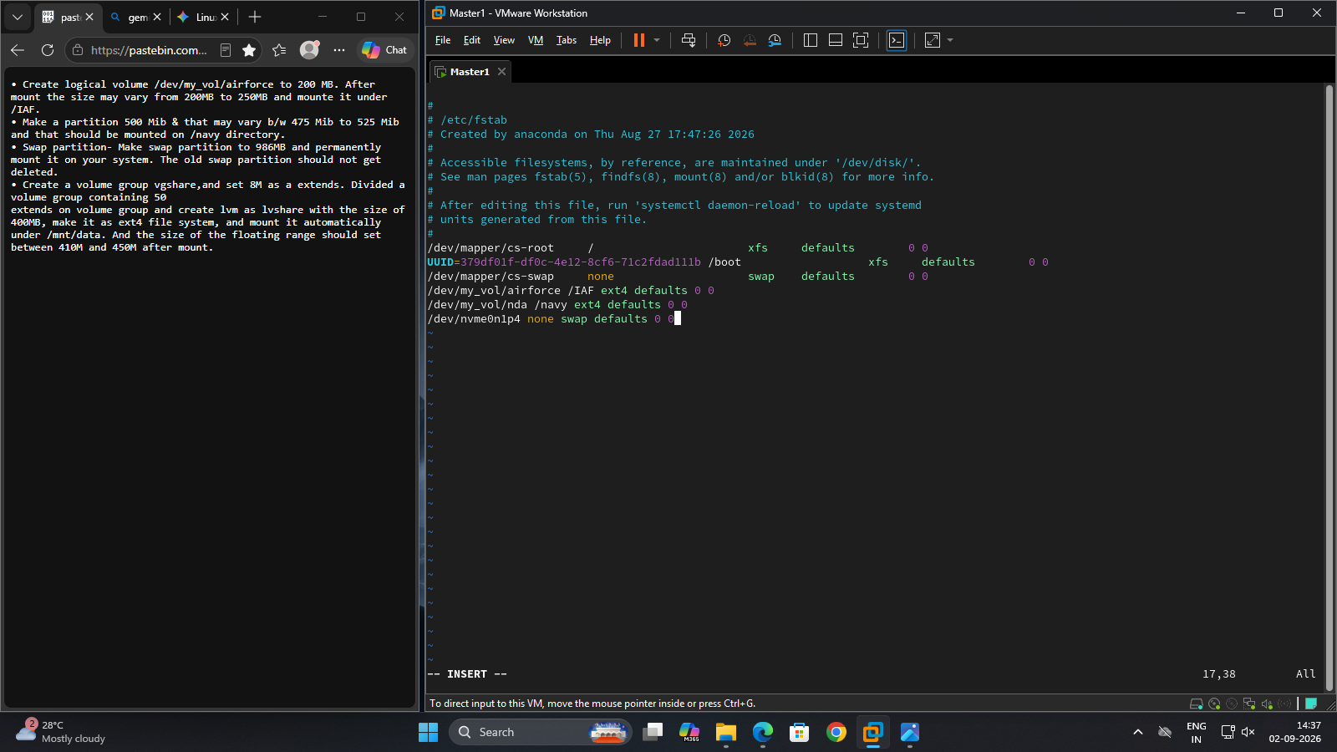
• Create a volume group vgshare,and set 8M as an extension. Divided a volume group
containing 50 extends on volume group and create lvm as lvshare with the size of
400MB, make it as ext4 file system, and mount it automatically under /mnt/data. And
the size of the floating range should set between 410M and 450M after mount.
